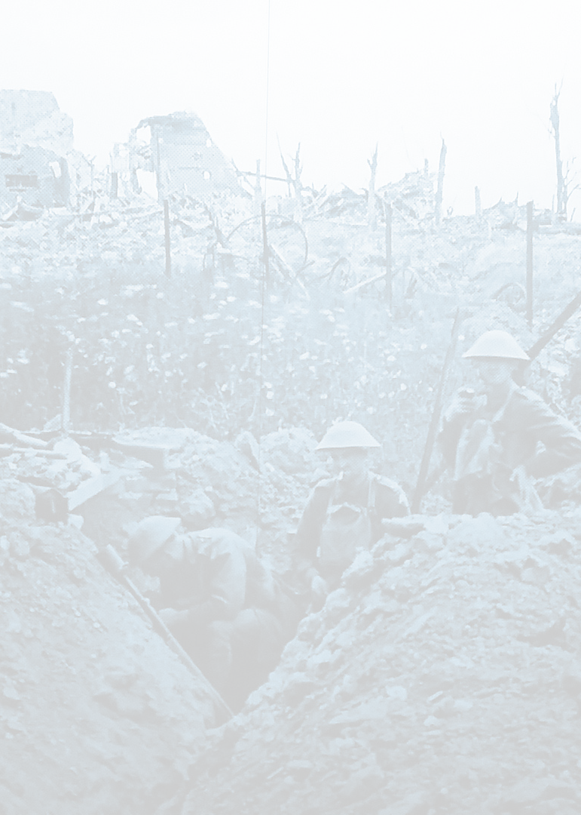
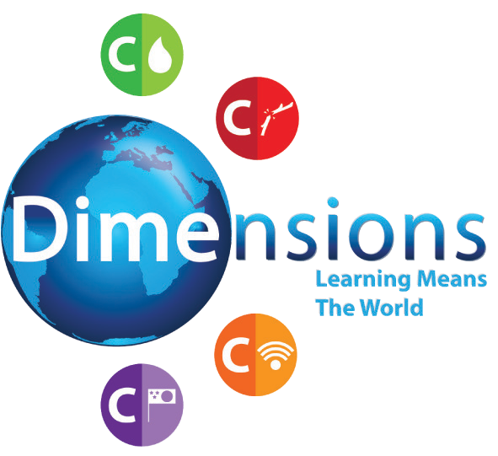
C

Curriculum Newsletter
Wars of the World
Theme Overview
“Wars of the World” is a thematic unit, based on conflicts past and present, with a key focus on history and geography. Pupils will learn about the root causes of war and have an understanding of its impact, focusing on the two World Wars in particular. They will also learn about civil wars and pacifism.
Science
Light
Maths Links
Fractions – Comparing, adding, subtracting, multiply and dividing fractions. Time.
Literacy Links
‘Letters from the Lighthouse’ by Emma Carroll
Art
Create a textiles poppy installation
Music
Wartime Songs

© Dimensions Curriculum Ltd.
Wish you’d... stop fighting

C

Curriculum Newsletter
Wars of the World
PSHE
Resilience Peer Pressure
Extremism and Radicalisation
Computing
E-Safety (PSHE link) Multimedia - Paint package

Home Learning

As Navigators, this is our weekly home learning expectation, so that the taught skills are reinforced and embedded.
- TT Rockstars - Daily Reading
- Spelling Shed

Creative Homework

• Imagine you are an evacuee. Write a postcard home to your family.
• Find out what the Enigma machine did and where it was based.
• Make a 3D model scene from WWII and write a poem to go with it.
• Create a peace charter, with a series of commitments and promises that can be shared with the school.

© Dimensions Curriculum Ltd.
Wish you’d... stop fighting

